AIM: To implement the K-Nearest Neighbors (KNN) classification algorithm and evaluate its performance using 5-fold cross-validation on the student dataset in Python.

ALGORITHM:
- Start the program.
- Import the Pandas library and the required functions from Scikit-learn.
- Load the student dataset from the data.csv file.
- Remove extra spaces from the column names.
- Select Hours studied, Attendance, and Assignment as input features.
- Select Result as the target variable.
- Split the dataset into training and testing sets in an 80:20 ratio.
- Display the number of training and testing samples.
- Create a KNN classifier with n_neighbors=3.
- Perform 5-fold cross-validation using cross_val_score().
- Display the cross-validation scores.
- Calculate and display the average accuracy.
- Stop the program.

OUTPUT:
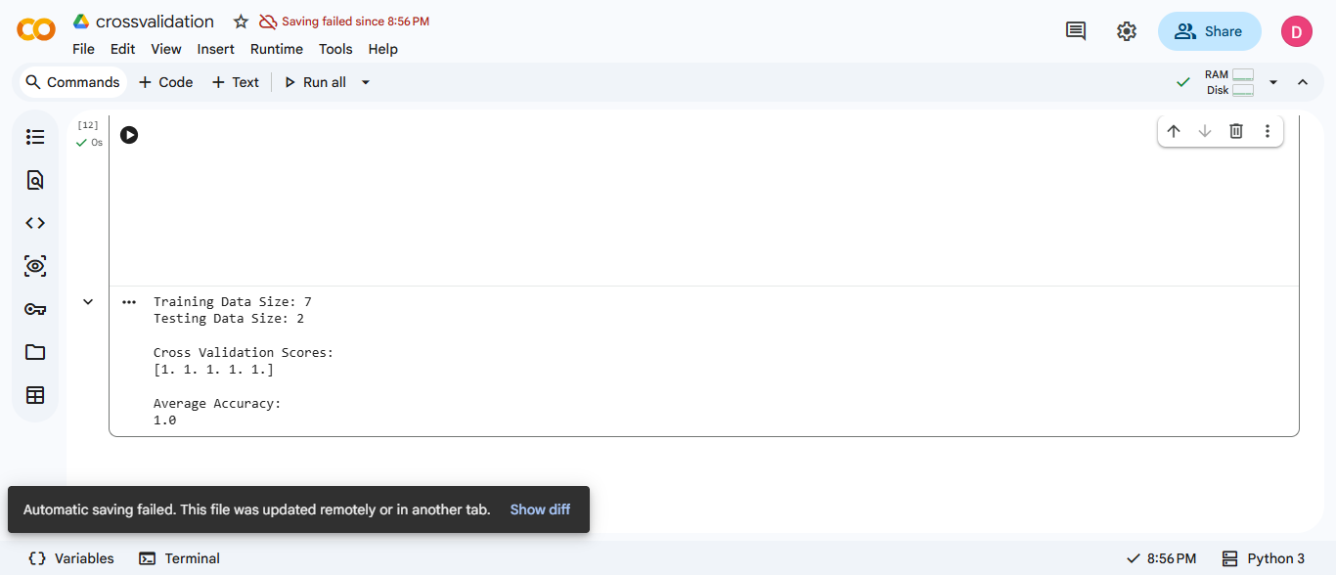

RESULT: Thus, the K-Nearest Neighbors (KNN) classification algorithm was implemented successfully on the student dataset, and its performance was evaluated using 5-fold cross-validation. The cross-validation scores and average accuracy were displayed successfully.

